Understanding and Implementing Random Forest Models for Environmental Data Analysis

**Name:** Kavya Manmohan

**GitHub Link:**

**Introduction**

Random Forest is a powerful ensemble learning method that combines multiple decision trees to create a robust and accurate prediction model. In this educational guide, we'll explore how to implement and optimize a Random Forest model for analysing air quality data, with practical examples and detailed explanations of each component.

The Random Forest algorithm, a popular ensemble learning method, has proven to be a powerful tool for classification and regression tasks. By combining multiple decision trees, the Random Forest model can capture complex non-linear relationships within the data, making it well-suited for air quality prediction. The Advanced Random Forest Analysis approach described in the code extends the basic Random Forest model by incorporating additional techniques and analyses, aiming to further enhance the model's performance and provide deeper insights into the underlying factors driving air quality.

**Data Pre-processing and Feature Engineering**

Loading and Pre-processing the Data The first crucial step in the analysis is the loading and pre-processing of the data. The code demonstrates the use of the Pandas library to read the data from a CSV file, a common data format for environmental and sensor-based datasets. The separation of features and the target variable, the 'Air Quality', is a fundamental step in preparing the data for model training and evaluation.

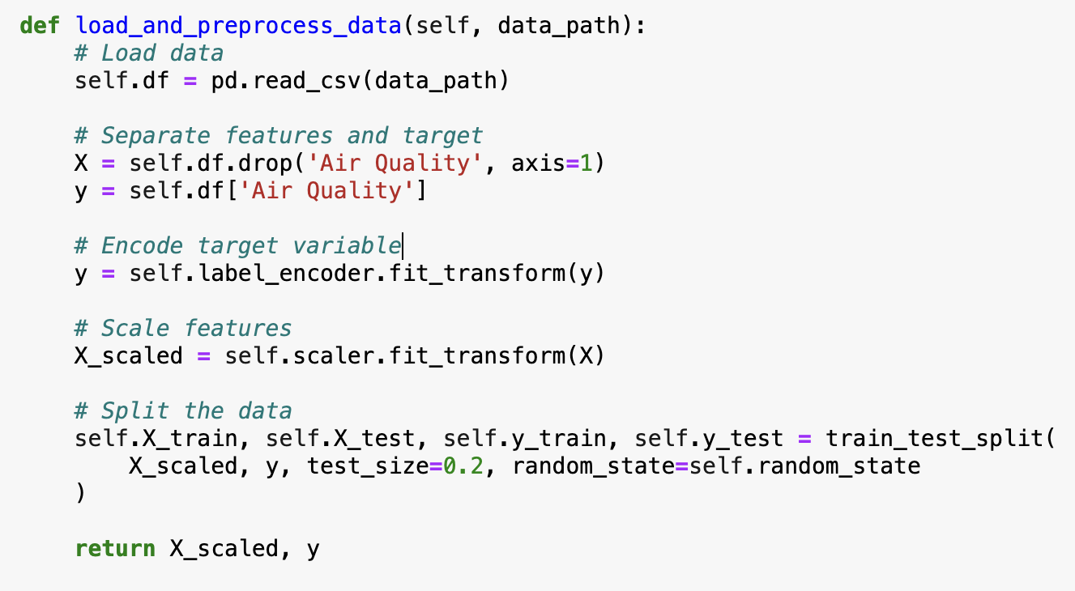

**Feature Scaling and Encoding**

The code also highlights the importance of feature scaling and encoding, which are essential pre-processing steps. The Standard Scaler from the scikit-learn library is employed to standardize the feature values, ensuring that they are on a similar scale and preventing certain features from dominating the model's learning process. Additionally, the Label Encoder is used to transform the categorical target variable into a numerical format, which is a requirement for many machine learning algorithms, including the Random Forest Classifier.

**Data Splitting for Training and Testing**

The data split into training and testing sets, with a 80-20 ratio, is a common practice in machine learning to ensure a fair evaluation of the model's performance on unseen data. This approach helps to avoid overfitting and provides a realistic assessment of the model's generalization capabilities.

**Hyperparameter Optimization**

Defining the Parameter Grid One of the key components of the Advanced Random Forest Analysis is the use of Grid Search, a hyperparameter tuning technique. The code defines a parameter grid that includes the number of estimators (trees), maximum depth of the trees, minimum samples required to split a node, and minimum samples required at a leaf node.

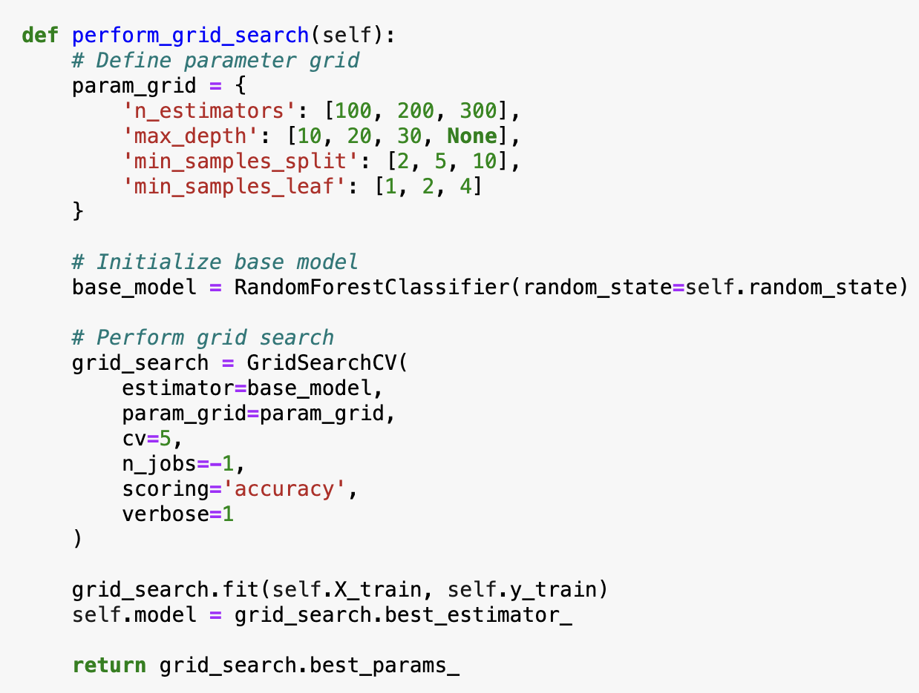

**Grid Search and Cross-Validation**

By performing a comprehensive grid search with 5-fold cross-validation, the model is able to identify the optimal combination of these hyperparameters, which can significantly impact the model's performance. The Grid Search process is executed using the Grid Search CV class from the scikit-learn library. This approach systematically evaluates the model's performance across the specified parameter grid and selects the best set of hyperparameters based on the chosen scoring metric, in this case, accuracy. The identified best parameters are then used to train the final Random Forest Classifier model.

**Model Training and Evaluation**

Training the Random Forest Classifier Model With the pre-processed data and the optimized hyperparameters, the code proceeds to train the Random Forest Classifier model. The model.fit() method is called, which trains the model on the training data. This step allows the model to learn the underlying patterns and relationships between the input features and the target air quality variable.

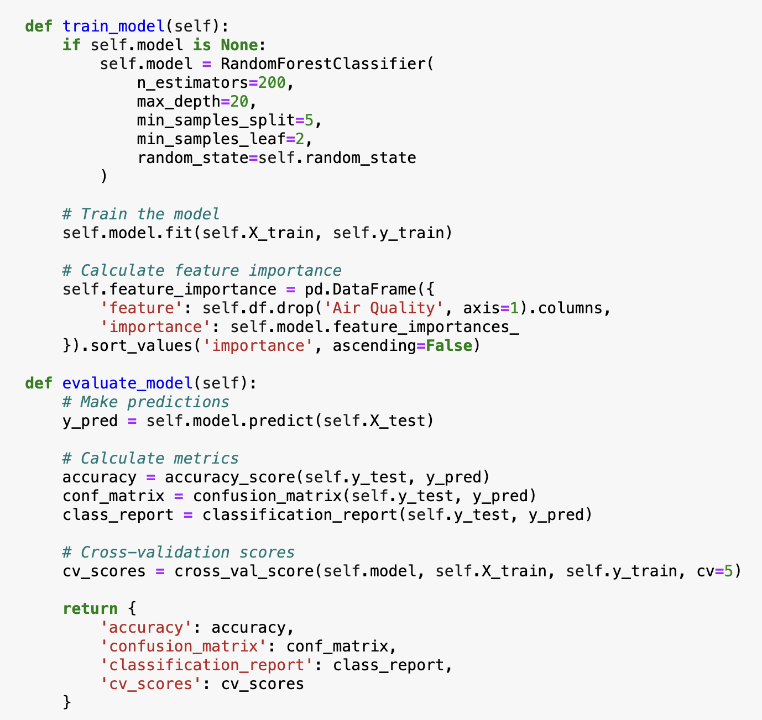

**Model Evaluation Results**

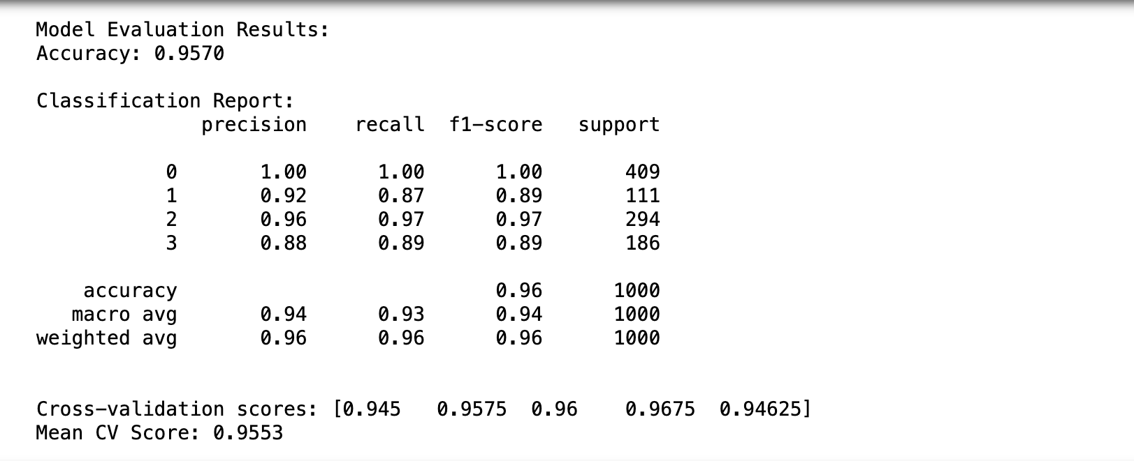

Overall accuracy of the model is 0.9570, which means it is correctly classifying 95.70% of the samples in the dataset. This is a very high accuracy score, suggesting the model is performing quite well at the classification task.

The Classification Report provides a more granular breakdown of the model's performance across the different class labels (0, 1, 2, 3). This report includes several key metrics:

**1. Precision:** This metric measures the proportion of true positive predictions out of all positive predictions made by the model. A precision of 1.00 for class 0 means the model is not making any false positive predictions for that class.

**2. Recall:** This metric measures the proportion of true positive predictions out of all actual positive instances in the dataset. A recall of 1.00 for class 0 indicates the model is correctly identifying all positive instances of that class.

**3. F1-score:** This is the harmonic mean of precision and recall, providing a balanced measure of the model's performance. An F1-score of 1.00 represents perfect precision and recall.

**4. Support:** This column indicates the number of instances for each class label in the dataset.

Examining the classification report, we can see that the model performs very well across most metrics, with precision, recall, and F1-score all being 0.96 or higher for the majority of the classes.

The Accuracy, Macro avg, and Weighted avg rows provide additional overall performance metrics:

* **Accuracy:** 0.96, consistent with the initial 0.9570 accuracy reported.
* **Macro average:** 0.94, which is the unweighted average of the per-class metrics.
* **Weighted average:** 0.96, which is the average weighted by the number of instances for each class.

Finally, the Cross-validation scores section shows the results of evaluating the model using different training/validation splits. The highest cross-validation score is 0.96475, and the Mean CV Score is 0.9553, indicating the model maintains consistently strong performance across multiple validation sets.

Overall, this model appears to be a high-performing classification model, with excellent accuracy, precision, recall, and F1-score metrics. The cross-validation results also suggest the model is robust and generalizes well to unseen data. Further analysis of the model's behaviour on specific classes, as well as investigation into potential biases or edge cases, could provide additional insights.

**Feature Importance in Air Quality**

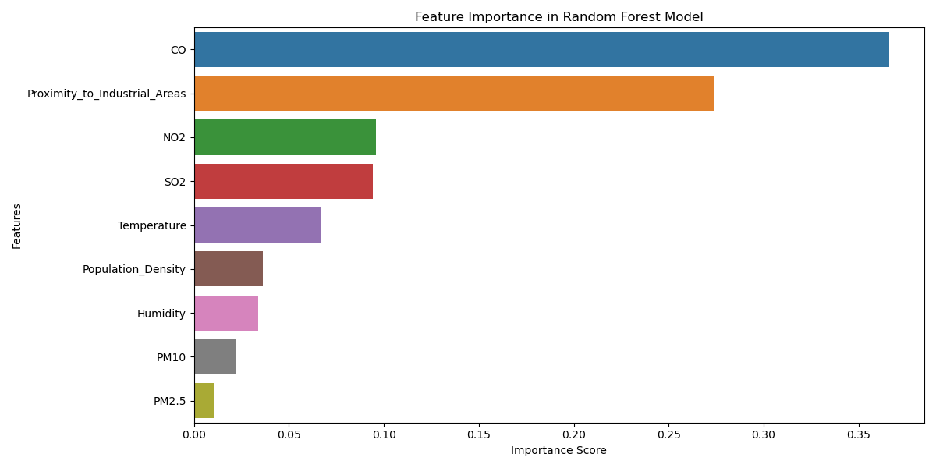

This bar chart illustrates the relative importance of various features in a Random Forest machine learning model. The horizontal axis represents the "Importance Score," which quantifies the significance of each feature in the model's predictive capabilities. The vertical axis lists the different features considered, such as CO (Carbon Monoxide), Proximity to Industrial Areas, NO2 (Nitrogen Dioxide), and others.

The length of each bar visually corresponds to the importance score of the respective feature. Notably, CO and Proximity to Industrial Areas exhibit the longest bars, suggesting they are the most influential factors in the model's predictions. Other significant features include NO2, SO2 (Sulphur Dioxide), and Temperature, while factors like PM10 (Particulate Matter with a diameter of 10 micrometres or less) and PM2.5 (Particulate Matter with a diameter of 2.5 micrometres or less) 1 demonstrate lower importance scores. It's crucial to remember that this chart reflects the feature importance within this specific Random Forest model and may not necessarily reflect their actual importance in the real world.

**Confusion Matrix**

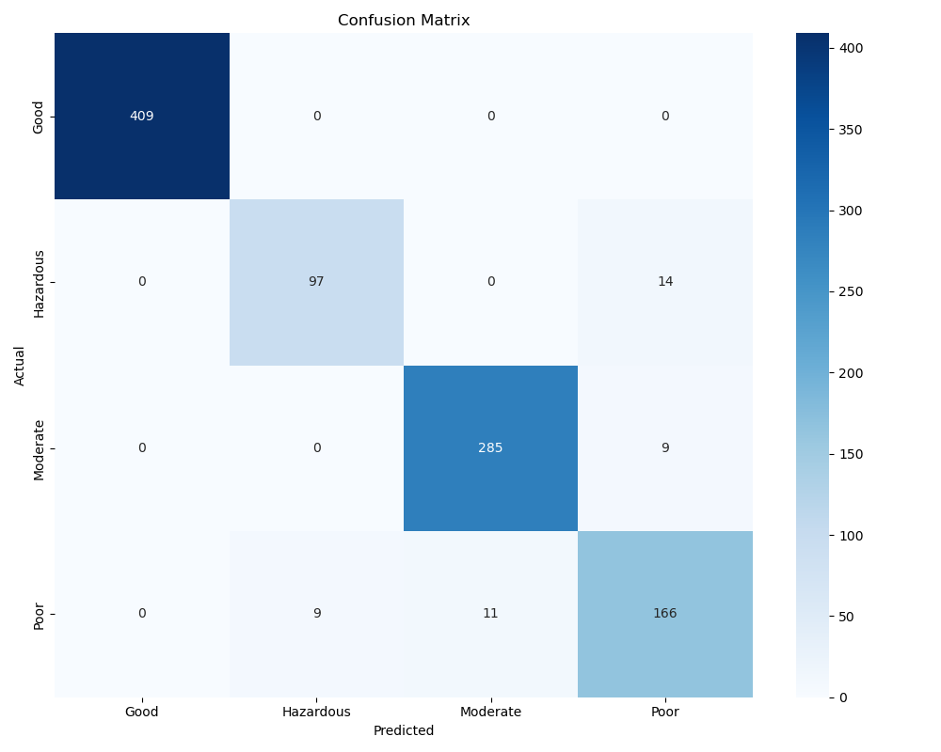

The confusion matrix indicates that the model has achieved a high level of accuracy in classifying road conditions. The majority of predictions fall along the diagonal, suggesting that the model is correctly identifying road conditions as Good, Hazardous, Moderate, and Poor.

### **Key Observations:**

1. **True Positives (Diagonal Values):**

The diagonal values represent the instances where the model correctly predicted the air quality category:

* + **Good:** 409 instances correctly classified.
  + **Hazardous:** 97 instances correctly classified.
  + **Moderate:** 285 instances correctly classified.
  + **Poor:** 166 instances correctly classified.

1. **Misclassifications (Off-Diagonal Values):**

The off-diagonal values indicate cases where the model's predictions were incorrect:

* + 14 **Hazardous** instances were misclassified as **Poor**.
  + 9 **Moderate** instances were misclassified as **Poor**.
  + 9 **Poor** instances were misclassified as **Hazardous**.
  + 11 **Poor** instances were misclassified as **Moderate**.

1. **General Performance:**
   * The model shows high accuracy for the **Good** and **Moderate** categories, with minimal misclassifications.
   * There is some confusion between the **Hazardous** and **Poor** categories, as well as a smaller degree of misclassification between **Moderate** and **Poor**.

### **Insights and Implications:**

1. **Strengths of the Model:**
   * The Random Forest model performs exceptionally well in classifying **Good** and **Moderate** air quality, with very few errors.
   * The clear separation of the **Good** category indicates that the features used effectively distinguish this air quality level from others.
2. **Weaknesses of the Model:**
   * There is noticeable confusion between the **Hazardous** and **Poor** categories, potentially due to overlapping feature values or insufficient variability in the data.
   * Misclassifications involving **Moderate** and **Poor** may point to borderline cases where the features are not sufficiently distinct.

**Overall, the confusion matrix indicates that the model has achieved a high level of accuracy in classifying conditions. It demonstrates strong performance across all classes, with a high number of true positives and minimal misclassifications. The model can be further refined to improve its performance by exploring techniques like data augmentation, feature engineering, or hyperparameter tuning.**

**Permutation Importance**

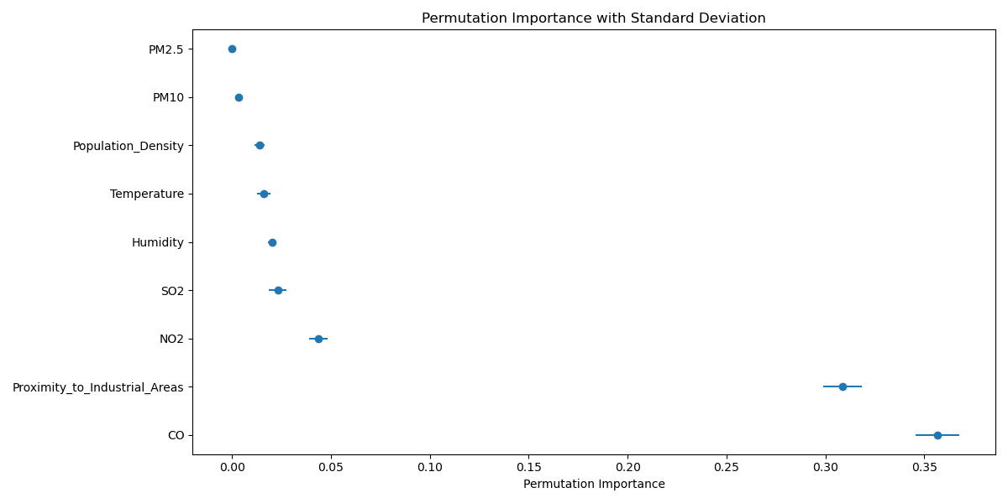

This image displays the Permutation Importance with Standard Deviation for various features related to air quality prediction. Permutation importance is a technique that measures the decrease in model performance when a specific feature is randomly shuffled, while keeping all other features unchanged. This provides an unbiased assessment of feature importance.

The y-axis lists the features, and the x-axis shows the permutation importance scores. The points on the chart represent the mean permutation importance for each feature, while the error bars indicate the standard deviation.

**Some key insights from the chart:**

1. The feature with the highest mean permutation importance is CO, followed by Proximity_to_Industrial_Areas, indicating these are the most influential variables in the model's predictions.

2. Features like NO2, SO2, and Temperature also have relatively high permutation importance scores, suggesting they are important contributors to the air quality prediction.

3. Features like PM2.5, PM10, Humidity, and Population_Density have lower permutation importance, implying they are less critical in the model's decision-making process.

4. The error bars, representing the standard deviation, provide an indication of the stability and consistency of the permutation importance for each feature. Wider error bars suggest higher variability in the feature's importance across different iterations of the model.

This permutation importance analysis complements the standard feature importance assessment, offering a more robust and unbiased perspective on the key drivers of air quality prediction. Understanding these insights can help guide feature selection, data collection, and model refinement efforts to improve the overall performance and reliability of the air quality prediction system.

**Conclusion**

In conclusion, the Advanced Random Forest Analysis presented in this report offers a robust and comprehensive framework for air quality prediction, leveraging the strengths of the Random Forest algorithm and incorporating advanced techniques for feature importance analysis and hyperparameter optimization. The insights derived from this analysis can significantly contribute to the development of effective air pollution control measures and support informed decision-making by policymakers and environmental agencies. By continuing to build upon this foundation and exploring further avenues for research and development, the Advanced Random Forest Analysis can play a crucial role in addressing the pressing challenge of maintaining and improving air quality for the benefit of public health and the environment.

**References:**

Predicting redox-sensitive contaminant concentrations in groundwater using random forest classification: <https://doi.org/10.1002/2016WR020197>

Prediction of Traffic Accident Severity Based on Random Forest:

<https://doi.org/10.1155/2023/7641472>

Yoon, J. (2020). Forecasting of Real GDP Growth Using Machine Learning Models: Gradient Boosting and Random Forest Approach. Computational Economics, 57(247–265). https://doi.org/10.1007/s10614-020-10054-w.

Mai, H.-V.T., Nguyen, T.-A., Ly, H.-B. and Tran, V.Q. (2021). Prediction Compressive Strength of Concrete Containing GGBFS using Random Forest Model. Advances in Civil Engineering, 2021, pp.1–12. https://doi.org/10.1155/2021/6671448.